

Journal of Smart Agriculture and Extension Service Volume1, Issue 1
Journal of Smart Agriculture and Extension Services (JOSAE)
Vol. 1 No. 1, June. 2023
www.Josaecares@fud.edu.ng

EVALUATION OF CLIMATE CHANGE AND RELATED ISSUES COVERAGES WITHIN SOME SELECTED NIGERIAN NEWSPAPERS
* A. Abubakar 1 , H. I. Ibrahim 2 and G.T. Adejare 1
1 Department of Agricultural Extension and Rural Development, Federal University Dutsin-Ma
2 Department of Agricultural Economics, Federal University Dutsin-Ma
*Corresponding Author Email: hassanishaqibrahim@gmail.com, +2348036239150
ARTICLE INFO. | ABSTRACT
Key words:  Climate Change, Newspapers Issues, Climate Change Coverage Prominence Assessment, Media Coverage | The study conducted a content analysis of four selected Nigerian daily newspapers namely; Daily Trust, Leadership, the Nation and Vanguard Newspapers in order to assess the coverage of climate change issues/stories by these newspapers. The study covered a period of three years (2020, 2021 and 2022). The objectives of the study were to determine the volume of coverage of climate change issues by selected Nigerian newspapers, compare the coverage of climate change issues amongst them, and assess the prominence given to climate change issues by Nigerian newspapers. The four selected newspapers were purposively chosen based on popularity in four regions, a total of 4380 issues of the 4 newspapers were obtained. Descriptive statistics was used to describe the coverage while One-way ANOVA was used to test differences in coverage between the four daily newspapers. The findings of the study revealed that the average coverage of climate change issues by the selected newspapers for the three years was 203 issues/stories, implying a low level of coverage. Leadership newspaper had the highest number of coverages with 187 issues/stories on climate change. The dominant form of presentation of climate change issues was in the form of a feature news. It was therefore recommended that the newspaper publishers should increase innovative coverage and passing of climate change issues including engaging Journalist in climate summits, workshops and conferences. The study also suggests leveraging on NGOs for a specialized trainings as well as promoting specialized coverage on climate change for effective climate based advisory services.
Introduction
Worldwide, observed and anticipated climatic changes for the twenty-first century and global warming are significant looking at the global climatic changes that have been encountered during the past 65 years. Climate change is a complex challenge globally, with its influence over various components of the ecological, environmental, socio-political, and socio-economic disciplines (Leal Filho et al. 2021; Feliciano et al. 2022). With the onset of the industrial revolution, the problem of earth climate was amplified manifold (Leppänen et al. 2014). African citizens are currently experiencing the impacts of increased surface temperatures, rising sea levels, changing precipitation patterns, droughts, and other consequences, even though they bear the least responsibility for the underlying causes. Lower crop yields are as a result of rising temperatures, flooding and droughts while heat stress and drought reduce livestock growth and output (Myers et al., 2017). The effects of climate change will be particularly severe in regions where agriculture is predominantly rain-fed such as in Sub-Saharan Africa, thus making it highly vulnerable to climate fluctuations and droughts (Adhikari et al., 2015; Cooper et al., 2008; Muchuru and Nhamo, 2019). Zougmoré et al. (2018) suggested that without appropriate interventions, climate change and variability will affect agricultural yields, food security and add to the presently unacceptable levels of poverty in sub-Saharan Africa. It is reported that the immediate attention and due steps might increase the probability of overcoming its devastating impacts. It is not plausible to interpret the exact consequences of climate change on a sectorial basis (Izaguirre et al. 2021; Jurgilevich et al. 2017), which is evident by the emerging level of recognition plus the inclusion of climatic uncertainties at both local and national level of policymaking (Ayers et al. 2014).
Usually, the media plays a critical role as they inform, educate, and engage people on the topic, helping to shape public opinion, influence policy decisions, and foster a collective response to one of the most pressing challenges of our time. Transforming the climate change narrative by disseminating crucial climatic data to effectively influence public discussions and enhance understanding of weather patterns and climate variability. Climate-smart agriculture is one of the means of adaptive measures to climate change issues. The media highlighting or even revealing the effect of climate change and shaping the perception of the populace. Some people read newspapers or magazines, or both, to keep up with what is going on in society, while others watch and listen to television and radio respectively. The media is responsible for establishing the issue and influencing how the public perceives particular problems, such as climate change science, politics, impact, and the need for action. extension methods can be used to spread news of existing knowledge on climate change and one of the agricultural extension strategies that has been documented is the employment of print media especially newspapers. Different extension methods can be used to spread news or existing knowledge about climate-smart agriculture, and one of the agricultural extension strategies that has been documented is the employment of print newspapers (Sala et al., 2016). Newspapers are periodical publications containing informative articles, editorial views, analytical articles, advertisements, special reports, pictures and cartoons. Newspapers can also provide sustained and prominent coverage on a particular subject and they are very important in increasing awareness, stimulating behavioral changes, Knowledge and skills development towards agricultural development. Therefore, newspapers play a notable role of disseminating developmental messages including agricultural information. Print media also has its fair share, amongst other media forms, in informing and creating awareness for the masses about the climate change and also its consequences and impacts. However, the opinion news in the print media gives more depth to issues like climate change. Newspapers engage columnists to present opinion articles i.e. columns to give more detailed analysis on the issue of climate change (Batta, 2013).
However, agricultural and other developmental challenges are often overshadowed in newspaper coverage in favor of business, political news, and other social topics. Globally, there is limited literature on newspaper coverage of climate change in particular. Previous studies had looked at agricultural news generally but none has looked at climate change in particular. Schmidt (2013) explains that the effects of climate change are globally present and frequently brought to media attention. The study illustrates that climate change has become a relevant media topic and thus the responsiveness of media to climatic issues has risen in many countries. However, the attention focused by media on it differs between the countries. Media attention on the matter of climate change is especially high in carbon dependent countries. This study seeks to contribute to the body of knowledge on the coverage of climate change by Nigerian newspapers, the specific objectives are to determine the volume of coverage on climate change issues by Nigerian newspaper and to assess the prominence given to climate change issues by Nigerian newspapers.
Research Hypothesis
H₀₁ There is no significant difference in the volume of coverage on climate change issues by the selected Nigerian newspapers.
H₀₂ There is no significant difference in the prominence given to climate change issues by the selected Nigerian newspapers.
METHODOLOGY
- Description of the Study Area
The study area for this research is the Federal Republic of Nigeria. Nigeria is a term coined out by a British reporter, Flora Shaw, which she took from the Niger River to apply to the region during the era of colonial rule. The capital city of Nigeria is Abuja. Nigeria comprises 36 States. Nigeria occupies a landmass of about 923,000km², and has latitude of 9.0820⁰N and longitude 8.6753⁰E. These coordinates place Nigeria in both the Northern and the Eastern hemisphere. Nigeria is unarguably the most populous nation in Africa and ranked number 7 globally with an estimated growth rate of 2.43 percent per annum and a high dependency ratio of 88 percent. Nigeria’s population is equivalent to 2.64% of the total world population and it is projected to reach 401million by 2050. (NPC/NBC, 2018; Otekunrin et al. 2019; Worldometer, 2020; World Data Lab, 2020).
Nigeria is a diverse and populous country located in West Africa. However, Nigeria boasts a varied terrain, encompassing vast plains, tropical rainforests, savannas, and plateaus. The country is renowned for its natural beauty, including the Niger River, which flows through its western region, and the Jos Plateau in the central part of the country. Nigeria is also home to numerous national parks and wildlife reserves, such as Yankari National Park and Gashaka-Gumti National Park. Regarding its population, Nigeria is one of the most populous countries in the world. Nigeria had a population of over 200 million people, making it the most populous country in Africa (NPC, 2021). The population of Nigeria is characterized by ethnic, cultural, and religious diversity, with over 250 different ethnic groups, including the Hausa, Yoruba, and Igbo, among others. Additionally, Nigeria's major cities, including Lagos, Kano, and Abuja, are highly urbanized and continue to experience rapid population growth and urbanization. The map of Nigeria is presented as Figure 1 below.
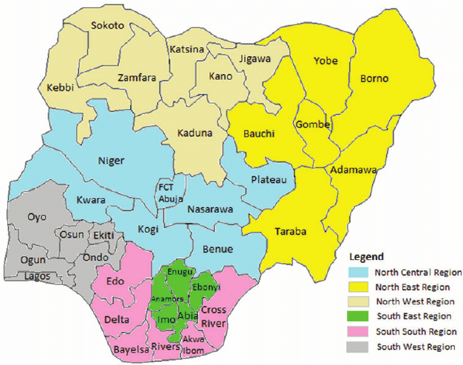
Figure 1: Map of Nigeria showing Geo-Political zones and states
- Population for the study
All printed newspapers published in Nigeria between January, 2020 and December, 2022 were used as the population for the study that is about 150 different newspapers in Nigeria.
- Sampling Technique
A purposive sampling technique was employed for the selection of four daily newspapers in Nigeria namely; Daily Trust, Leadership, The Nation and Vanguard newspapers. The four newspapers were purposively selected based on location or regions’ preferences (Northern and Southern part of Nigeria) and also due to their circulation strength, readership, wide coverage of issues and popularity within geographical locations. All editions of the four Newspapers published in 2020/2021/2022 were sampled, making a total of 4,380 editions for the four daily Newspapers.
- Method of Data Collection
Data was collected from the hard copies of the selected newspapers via content analysis. Content analysis is a powerful empirical method for analyzing text, a method that technical communicators can use on the job and in their research. Data collection was done by the authors and ten (10) trained research assistants. The following analysis was employed in the study to help guide the coding of the selected newspaper samples:
- Volume of coverage: This is the total number of climate change issues reported by the selected newspaper.
- Prominence: This refers to the importance giving to the story on climate change issues. The following are the parameters used to determine the prominence giving to climate change issues.
- Placement: This refers to the forms in which issues on climate change appeared in the newspaper i.e., on a front page, back page or center page.
- Treatment: This refers to the forms in which issues on climate change were presented in the newspapers i.e., as feature stories, opinion articles, interviews and letters to editor.
- Illustration: This refers to the forms in which issues on climate change appeared in the newspapers i.e., as photographs, tables or charts.
- Data Analysis
Descriptive statistics was used to describe the coverage while One-way ANOVA was used to test volume differences in coverages between the four daily newspapers.
RESULT AND DISCUSSION
Volume of coverage on climate change issues
 | Table 1: Volume of Coverage of Climate change issues by some Selected Nigerian Newspapers (2020-2022)
S/N | Items | 2020 |  |  | 2021 |  |  |  | 2022
 | Selected  Newspapers | Issues | Freq. | Percentage | Issues | Freq. | Percentage | Freq. | Issues | Percentage | Mean
i. | Daily Trust | 295 | 26 | 9 | 336 | 70 | 21 | 355 | 62 | 17 | 53
ii. | Leadership | 294 | 58 | 20 | 341 | 63 | 18 | 341 | 66 | 19 | 62
iii. | The Nation | 303 | 49 | 16 | 349 | 66 | 19 | 356 | 55 | 15 | 57
iv. | Vanguard | 300 | 20 | 7 | 352 | 41 | 12 | 355 | 35 | 10 | 32
The volume of coverage on climate change in the selected four daily newspapers over three years is presented in Table 1 and Figure 2 respectively. The results revealed that the total volume of coverage on climate change issues for the three years was 153, 240 and 218 issues/stories in 2020, 2021 and 2022 respectively. The three-year average coverage is 203 issues/stories. This shows that the volume of coverage of climate change by these newspapers is low. A study by Nwabueze et al., (2015) on content analysis of three national Dailies (Vanguard, Guardian and Daily Sun Newspapers) found that the volume of coverage of climate change issue is poor and that the dominant form of presentation was feature stories. The current study disagrees with the findings of Fawole & Olajide (2012) in their study titled “reporting of climate change news in three selected Nigerian newspapers” to investigate the reportage of climate change news in Nigeria. A content analysis of the Guardian, Punch & Nigerian Tribune was carried out. Findings from the research show that the newspaper coverage of climate change news was widespread covering all areas of climate change. In addition, the findings of the current study corroborate with the study of Batta et al., (2013) in a study titled “press coverage of climate change issues in Nigeria and implications for public participation opportunities” content analysed selected daily Nigerian newspapers to find out how climate change issues are covered and framed in Nigerian 26 newspapers. Findings from the research show a low representation of climate change in the newspapers.
Source: Authors’ Compilation (2023)

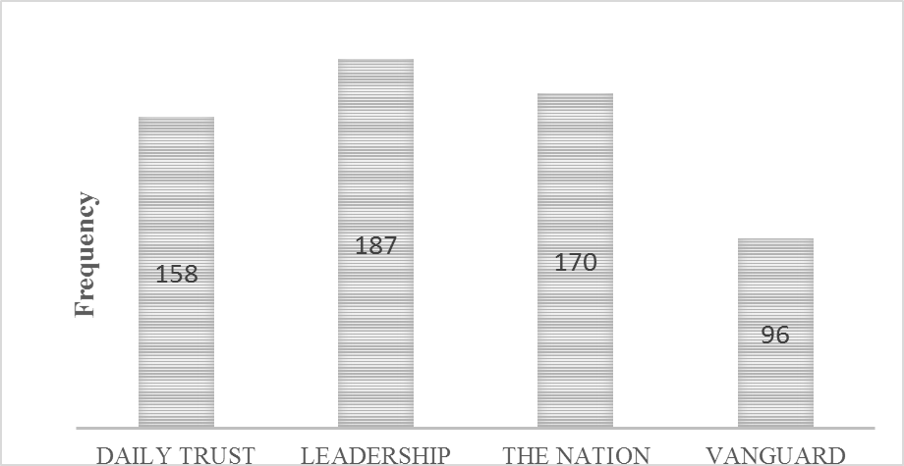
Figure 2: Total coverage of climate change by selected newspapers for three years
Table 2 presents a one-way analysis of variance of the volume of coverage on climate change issues. The result revealed that that there is no significant difference in the volume of coverage on climate change issues among the newspapers.
Table 2: Comparison of the Volume of Coverage on Climate Change by Newspapers
 | Sum of Squares | Df | Mean Square | F | Sig.
Between Groups | 2462.91 | 3 | 820.97 | 2.24 | .161
Within Groups | 2929.33 | 8 | 366.16
Total | 5392.25 | 11
Source: Authors’ Compilation (2023)
The result in Figure 3 further revealed that Leadership newspaper had the highest coverage in 2020 with 58 stories. Daily Trust Newspaper had the highest coverage in 2021 with 70 stories while Leadership newspaper had the highest coverage in 2022 with 66 stories.
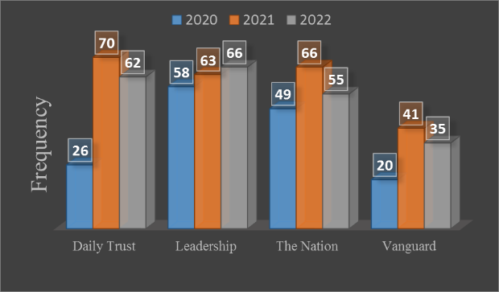

Figure 3: Total coverage on climate change issues by selected Newspapers (2020-2022)

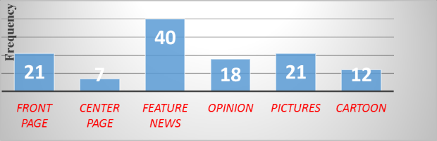

Figure. 4: Prominence of climate change in Daily Trust newspaper (2020-2022)
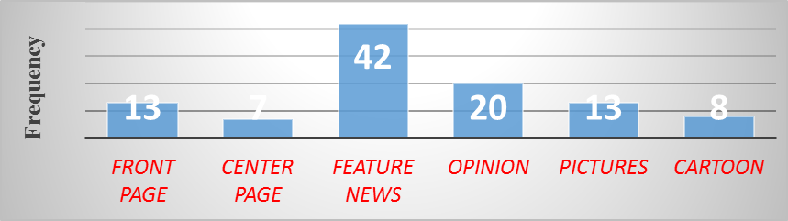

Figure 5: Prominence of climate change in Leadership newspaper (2020-2022)

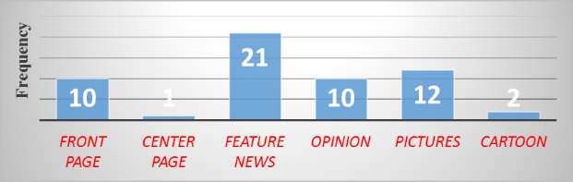

Figure 6: Prominence of climate change in Nation newspaper (2020-2022)
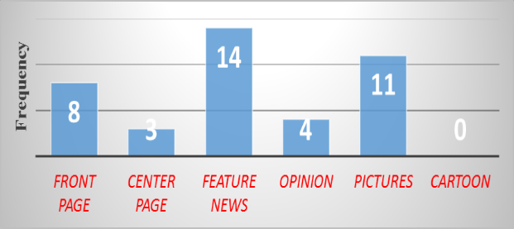

Figure 7: Prominence of climate change in Vanguard newspaper (2020-2022)

Prominence given to Climate Change issues by Nigerian Newspapers
Results in Figure 4 shows the that Daily Trust newspapers accorded prominence to climate change issues in the form of Feature news followed by front page and pictures. It can be observed from Figure 5 that Leadership newspapers accorded prominence to climate change issues in the form of Feature news followed by opinions. Figure 6 revealed that the Nation newspapers had more issues on climate change issues in the form of feature news followed by Pictures. Figure 7 indicates that Vanguard newspaper also gave importance to climate change issues in the feature news and Pictures. Therefore, feature news is the dominant way of according prominence to climate change issues by all the selected newspapers. The use of front page was seldom done by the newspapers. This has the effect of readers missing out on the coverage of climate change issues especially if their attention is more on the front page.
Table 3 presents one-way analysis of variance on the prominence of climate change issues. The result revealed that there is a significant difference in the prominence given to climate change coverage by the newspapers. This implies that though the use of feature news is common among the newspapers, no two newspapers gave prominence in the same way to climate change issues.
Table 3: One Way ANOVA Analysis of the Prominence on Climate Change
Prominence of climate | Sum of Squares | Df | Mean Square | F | Sig. | Dec.
Total Between Groups  Within groups  Total | 5735.00 1610.91  346.00  1956.91 | 11  3  8  11 | 536.97  43.25 | 12.41 | .002 | Sig.
Source: Authors’ Compilation (2023)
Conclusions
Based on the findings of the study, it can be concluded that although Leadership newspaper had the high total coverage of climate change issues with 187stories, Yet, coverage of climate change information by the selected newspapers in the study area is generally very low. The major form of prominence accorded to climate change issues was in the form of feature news as opposed to front page placement. Priority was thus given to advertisements, business, politics, sports and entertainment news by the newspapers. However, there is a significant difference in the prominence given to climate change issues by the selected newspapers.

Recommendations
Based on the findings of this study, the following recommendations are made:
- Newspaper publishers should increase the coverage of and improve on the prominence giving to agricultural news most especially those relating to climate change in a bid to foster sustainable agricultural development.
- Reporting of climate change issues needs to be prioritized by the press, if they are to fulfill their role in providing timely and effective information on climate change.
- Journalists training and collaboration with national stakeholders and perhaps NGOs for a specialized trainings as well as promoting specialized coverage on climate change would assist in more effective climate change coverage, instead of the great reliance on one-off events to spark recognition of the major environmental problem.
Acknowledgements
The authors sincerely appreciate the Tertiary Education Trust Fund (TetFund), for funding the research under its Institutional Based Research (IBR) grant program.

References
Adhikari, U., Nejadhashemi, A. P., & Woznicki, S. A. (2015). Climate change and eastern Africa: a review of impact on major crops. Food and Energy Security, 4(2), 110-132.
Batta, H.E. Ashong, A.C. & Bashir, A.S (2013), Press coverage of climate change issues in Nigeria and implications for public participation opportunities. Journal of Sustainable Development, 6(2), 56-70.
Fawole, O. P & Olajide, B.R. (2012). Reporting of climate change news in three Nigerian
newspapers. Journal of Agricultural Extension, 16(1), 31-42.
Myers, S. S., Smith, M. R., Guth, S., Golden, C. D., Vaitla, B., Mueller, N. D., ...&Huybers, P. (2017). Climate change and global food systems: potential impacts on food security and undernutrition. Annual review of public health, 38, 259-277.
Nwabueze, C, Nnaemeka, F, Umeora, D and Okika, E (2015), Nigerian newspapers‟ coverage of climate change issues, European Scientific Journal, 11(17), 1857-1881.
Otekunrin, O. A & Otekunrin, O. A (2019). Healthy and Sustainable Diets: Implications for Achieving SDG2. W, Leal Filho, A, Azul, Brandli., P, Ozuyar& T Wall (eds) Zero hunger. Encyclopedia of the UN Sustainable Development Goals. Springer: Cham Publishers.
Sala, O. E., Stuart Chapin, F. I. I. I., Armesto, J. J., Berlow, E., Bloomfield, J., Dirzo, R., & Wall, D. H. (2016). Global biodiversity scenarios for the year 2100. science, 287(5459), 1770-1774.
Schmidt, A. Ivanova, A. and Schafer, M.S, (2013). What drives media attention for climate
change? Explaining issue attention in Australian, German and Indian print media
from 1996 -2010. The International Communication Gazette: Sage Publication.
Zougmoré, R. B., Partey, S. T., Ouédraogo, M., Torquebiau, E., & Campbell, B. M. (2018). Facing climate variability in sub-Saharan Africa: Analysis of climate-smart agriculture opportunities to manage climate-related risks. Cahiers Agricultures (TSI), 27(3): 1–9. https:// doi.org/10.1051/cagri/2018019

